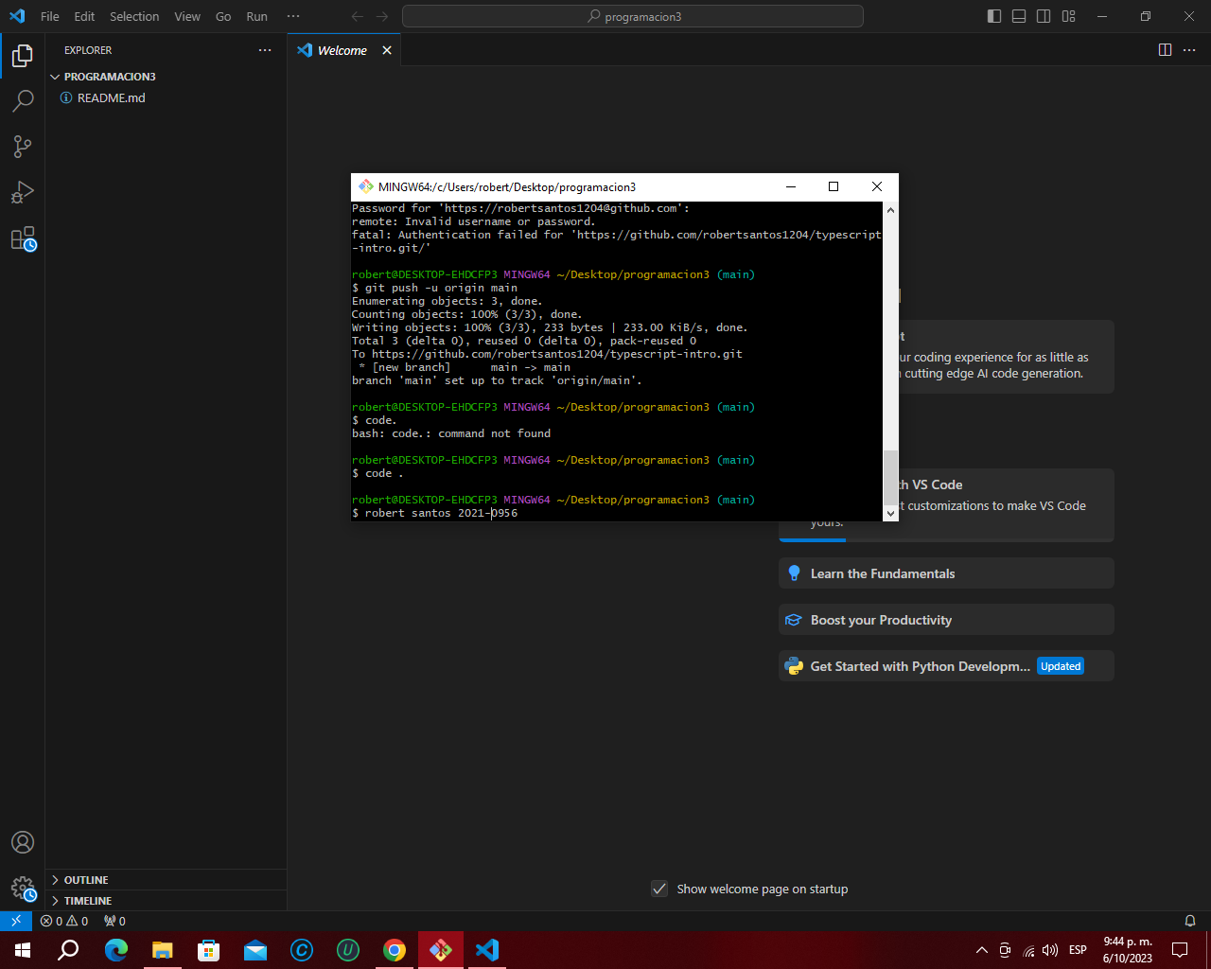

<https://github.com/robertsantos1204/typescript-intro.git>